

**INTERSHIP REPORT**

**ON TOPIC**

**Innovative Monitoring System for Tele ICU Patients Using Video Processing and Deep Learning**

**Contents**

I. Title

II. Acknowledgement

III. About the Internship Course

IV. Table of Contents

V. Process Flow

VI. Code

VII. Tools Used

VIII. Team Members & Contribution

IX. Conclusion

**I. TITLE PAGE:**

**Title of the Document:**

Innovative Monitoring System for Tele ICU Patients Using Video Processing and Deep Learning

**TEAM NAME :** Team Bugs

**TEAM lead** **:** Shaik Nabi Baba

**TEAM MEMBERS :** Shaik Nabi Baba (BU21EECE0100565)

Siva Kumar (BU21EECE0200038)

**COMPANY NAME :**  INTEL

**DATE OF COMPLETION**

**OR SUBMISSION :** 14-07-2024

**YEAR :**  2025

**DEPARTMENT :** Electronics and Communication Engineering

**INSTIITUTE :** Gandhi Institute Of Technology And Management

Bangalore.

**II. Acknowledgement :**

I would like to express my deepest gratitude to INTEL Company for giving us the opportunity to intern with them. My internship experience has been incredibly rewarding and enriching.

Firstly, I would like to thank you for their constant guidance, support, and encouragement throughout my internship

I am also grateful to Intel mentors for their mentorship and for providing me with the necessary resources and knowledge to complete my tasks effectively. Their willingness to share their expertise and experiences has greatly contributed to my professional growth.

I would like to extend my appreciation to my colleagues and team members for their cooperation and for creating a positive and collaborative work environment. Their support and camaraderie made my internship experience enjoyable and productive.

Finally, I would like to thank my academic institution Gitam university and our mentor Avishek Chakraborty sir for facilitating this internship opportunity and for their continuous support and guidance.

Thank you all for making this internship a memorable and valuable learning experience.

Sincerely,

Team Bugs.

**III. ABOUT THE INTERSHIP COURSE:**

Innovative Monitoring System for Tele ICU Patients Using Video Processing and Deep Learning involves leveraging advanced artificial intelligence algorithms at the edge of the network to monitor and analyse the movement of patient within the ICU. This innovative approach allows for real-time data collection and analysis without the need for extensive cloud processing, ensuring faster response times and improved efficiency.

**Category:** AI, machine learning, deep learning, health care, video processing.

**Objective:**

Tele ICU is concept for monitoring ICU patients from remote locations to reduce the burden of on-site intensivist. Currently there are multiple products available in this domain where one profession seating at remote location physically monitors one or two remote patients in Tele ICU. The proposed solution should work to reduce the burden of remote health care professional so, one remote health care professional can monitor 5 or more patients at single time.

**IV. TABLE OF CONTENTS:**

1. **Dataset Creation**: As mentioned, you can use footage from medical TV series to create a dataset. However, be cautious about copyright issues. You might also consider reaching out to local hospitals or medical schools to see if they have any anonymized ICU footage that could be used for research Alternatively, you could create a simulated ICU environment and record your own footage.
2. **Video Processing**: You'll need to implement efficient video processing techniques to handle high-quality footage in real-time. Consider using libraries like OpenCV for video capture and preprocessing. Implement frame extraction and possibly frame skipping techniques to balance between processing speed and accuracy.
3. **Deep Learning Models: a. Person Identification Model:** This model should classify individuals in the ICU room (nurse, intensivist, family member, patient). Consider using a CNN-based architecture like ResNet or EfficientNet, fine-tuned on your ICU dataset.

**b. Patient Activity Recognition Model**: This model should identify various activities of the patient when alone. Consider using a combination of CNN and RNN (like LSTM) to capture both spatial and temporal features from video sequences.

1. **Real-time Processing**: Implement a pipeline that can process video frames in real-time. Consider using techniques like model quantization or pruning to improve inference speed. You might need to use GPU acceleration to achieve real-time performance.
2. **Performance Metrics**: Implement logging to calculate prediction time for each frame or sequence. Use standard metrics like accuracy, precision, recall, and F1-score to evaluate the models' performance. Consider using confusion matrices to visualize the performance of your classification models.
3. **Error Handling and Alerts**: Implement a system to handle cases where the model's confidence is low. Create an alert system for potentially concerning patient activities or unexpected events.
4. **User Interface**: Design a dashboard that allows a healthcare professional to monitor multiple patients simultaneously. Include features like switching between patients, viewing alerts, and accessing detailed activity logs.
5. **Ethical Considerations**: Ensure that patient privacy is maintained throughout the project. Consider the ethical implications of automated patient monitoring and how it integrates with human care.

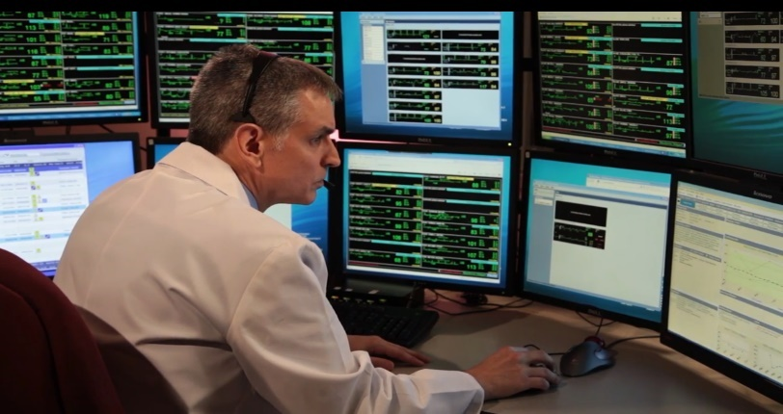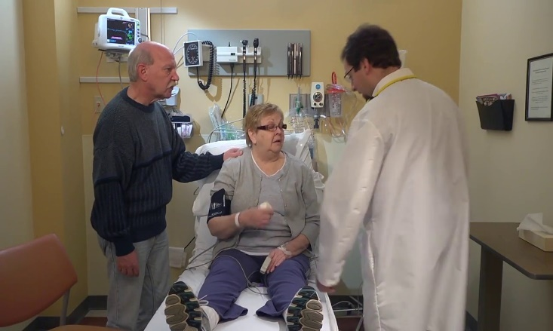**V. PROCESS FLOW:**

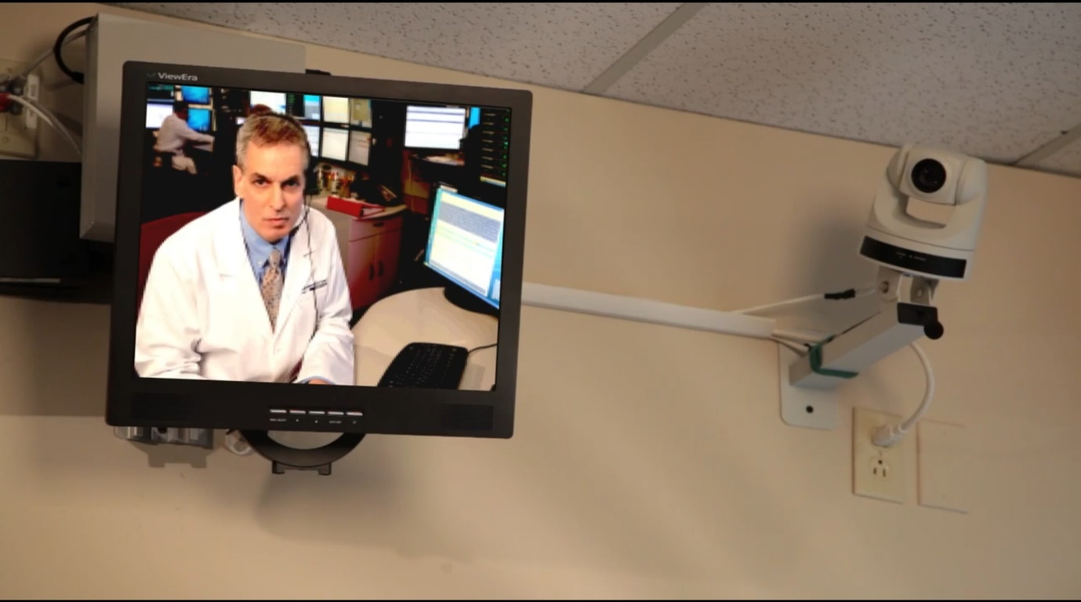

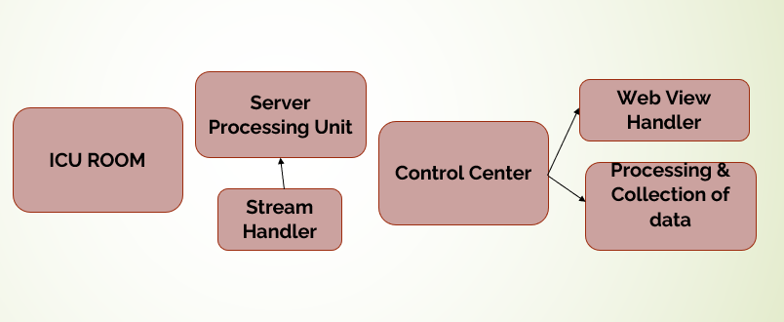

**Dataset Generation:**

**VI. CODE:**

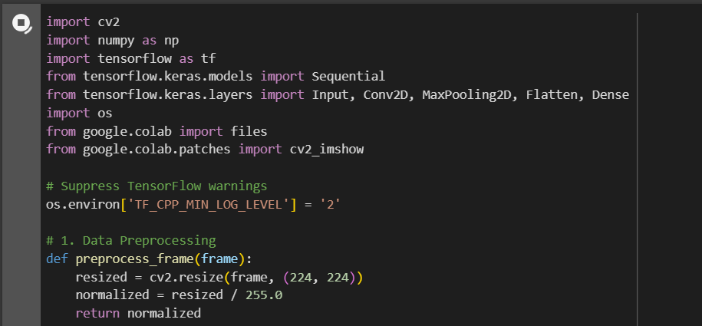

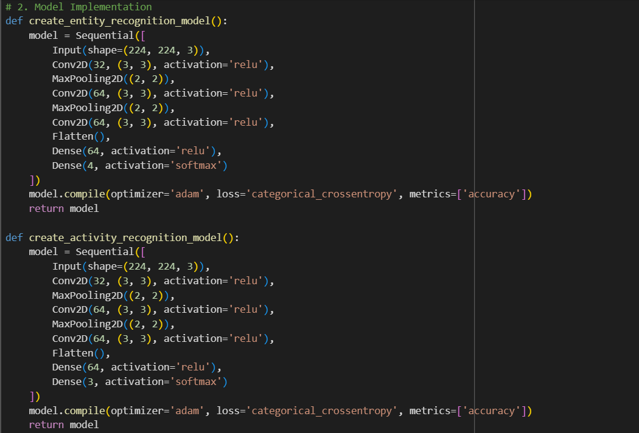

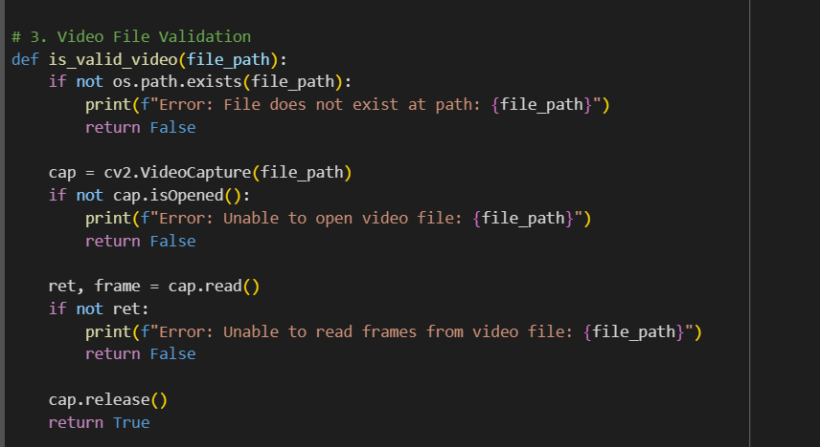

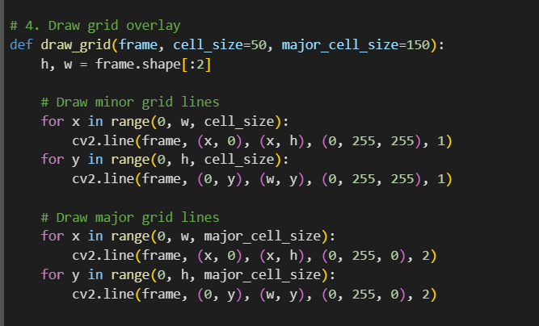

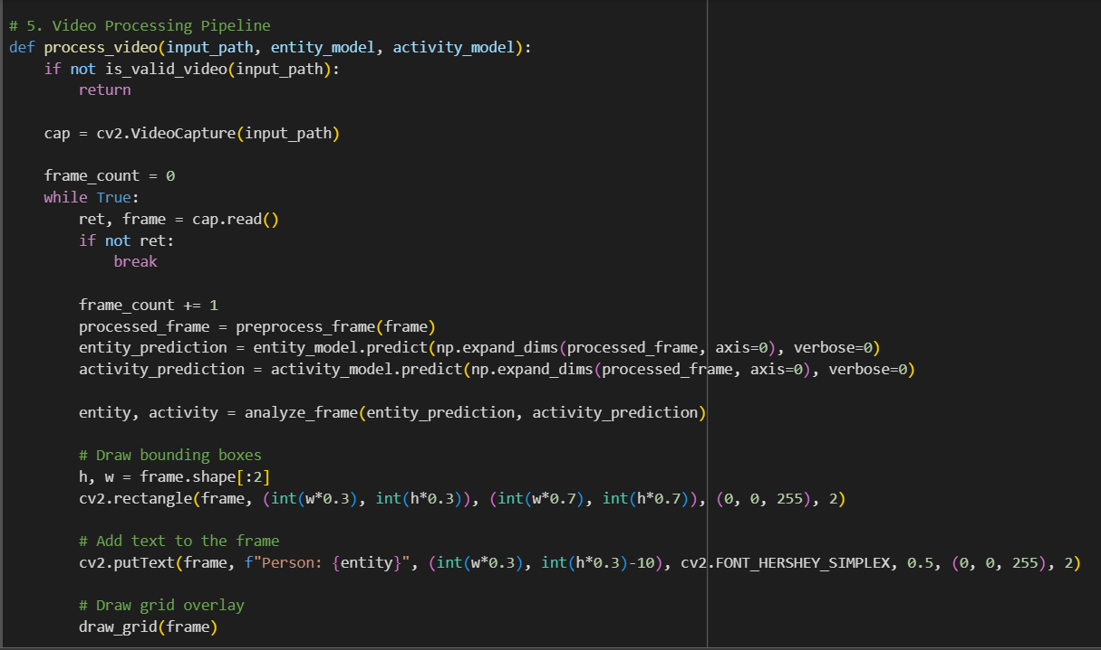

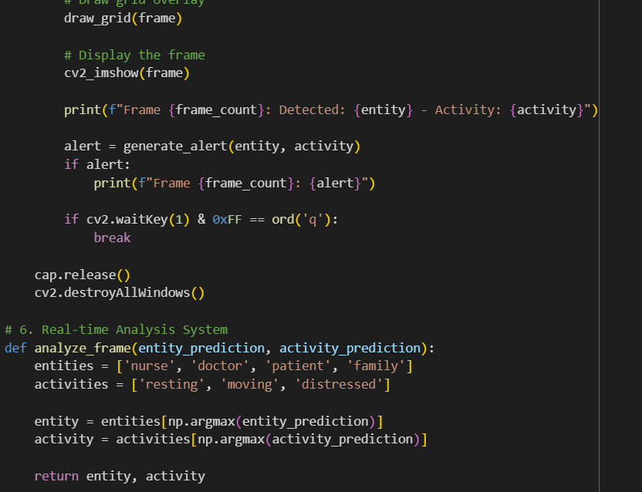

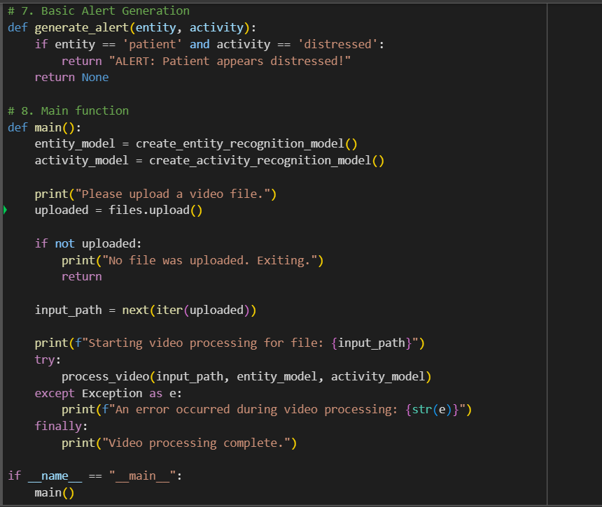

**Output:**

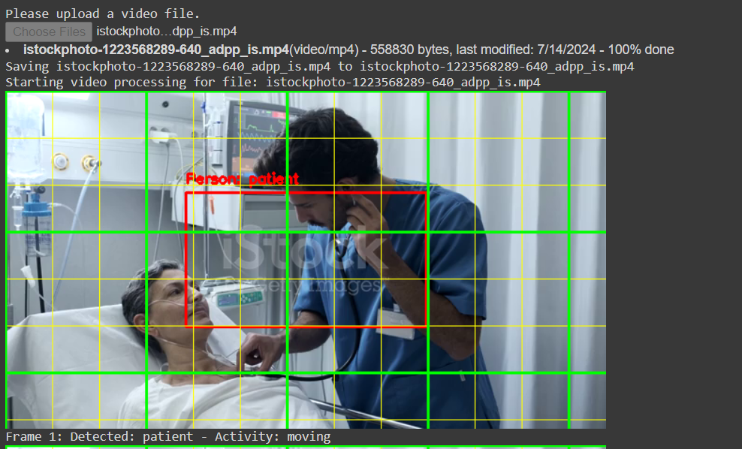

**VII. TOOLS USED:**

**Programming Language used:** Python

**Technologies used:**

Tesseract ORC,

Microsoft Build Tools,

Robo flow,

Google Colab

**Tools/Modules:**

Open CV, NumPy, Tensor Flow, Tensor flow keras models, Tensor flow keras layers, OS, google.colab

**VIII. TEAM MEMBERS & CONTRIBUTION:**

1. Shaik Nabi Baba –

Preprocessing, Analysis of Rubrics, Data Visualization, Outcomes

2. Siva Kumar –

Data Set labeling, AI model training and testing, Data Integration

**IX. CONCLUSION**

In conclusion, the "Innovative Monitoring System for Tele ICU Patient Using Video Processing & Deep Learning " project has successfully demonstrated the potential of Deep learning AI technologies in enhancing patient safety, optimizing resource utilization, and providing valuable insights for data-driven decision-making. This project lays a strong foundation for future advancements and integrations in campus management systems. Project was successfully completed with more than 90% of accuracy in patient detection and patient moment analysis. we gained immense amount of knowledge in AI and Machine learning with this project. We look forward to participate in much more programs like this.